ANSI/APA PRG 320-2017 (Recirculation Ballot 2017-6-R1 Header)
Ballot issue date: 09/25/2017 Ballot closing date: 10/02/2017

Ballot Instructions:
- This is a recirculation ballot to Ballot 2017-6, which was issued on 07/18/17 and closed 08/18/17. This recirculation ballot affords all members of the Committee an opportunity to respond (if you didn’t vote before), reaffirm (vote the same way as you did last time), or change their vote. If, however, you previously voted during the letter ballot and do not wish to change your vote, no action is necessary and your vote will be counted as previously cast (unchanged). If you wish to vote the same way, you are free to vote again on this ballot. If you did not vote previously, you may choose to complete and return this ballot.
- Ballot 2017-6 received a negative vote when it was closed, but the negative vote was subsequently changed to affirmative with comments after further communications by the Task Group and the Secretariat. Therefore, there were no negative votes on this ballot. However, the Task Group suggested some minor changes in response to comments.
- If this recirculation ballot do affect your previous vote, you must cast your new vote by returning this ballot. Note that if you are changing your vote to an “affirmative with comments” or “negative” vote, you must submit written comments in order for your vote to be counted.
- This ballot is only open for 7 calendar days (closes on Monday, October 2, 2017).
- Please return your ballot by e-mail to borjen.yeh@apawood.org.

Committee Member Name |  | Signature (not required with e-mail) |  | Date

Ballot (Aff = affirmative; Aw/C = affirmative with comment; Neg = negative; Abst = abstention)

Item | Description | Aff | Aw/C | Neg | Abst
2017-6-01-R1 | Revise terminologies
2017-6-02-R1 | Replace Section 4, Symbols, as marked
2017-6-03-R1 | Revise labels in Tables A2 and A4
2017-6-04-R1 | Add in-plane shear and edgewise bending test methods

Ballot Comment Form for ANSI/APA PRG 320-2017 (Recirculation Ballot 2017-6-R1 Header)
Required only for Negative or Affirmative-with-Comment
Please attach this page to the e-mail ballot return

Item | Comments
2017-6-01-R1
2017-6-02-R1
2017-6-03-R1
2017-6-04-R1

Headers Related Revisions
Ballot 2017-6 Headers

Notations: Inserted Text New Text (from original Ballot 2017-6)
Deleted Text Old Text (from original Ballot 2017-6)

Item 2017-6-01: Revise terminologies as follows.
Rationale: Update the terminology for consistency with the revisions of this standard. Add new terminology for Edgewise and Flatwise bending for clarification. Add Figures for clarity.

Ballot: Add terms to Section 3.2 as follows.

3.2 Terms Specific to This Standard
Edgewise Bending – bending of CLT under loads applied to the panel edge (see Figure 1) creating in-plane bending and edgewise shear, also known as in-plane shear or shear through the thickness (see Figure 1)

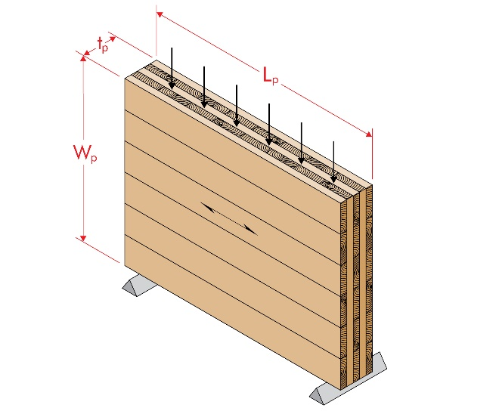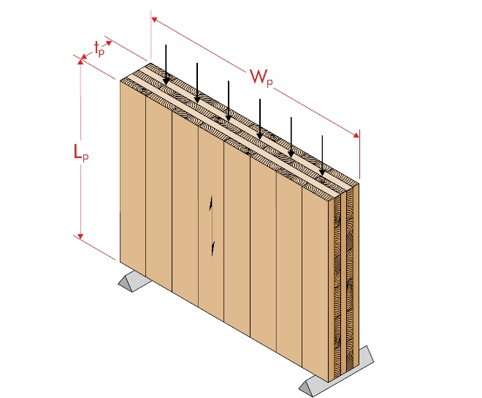
Figure 1. Edgewise bending in the major (left) and minor (right) CLT strength directions

Flatwise Bending – bending of CLT under transverse loads applied to the panel face (see Figure 2) creating out-of-plane bending and flatwise shear, also known as planar, or rolling shear (see Figure 2)

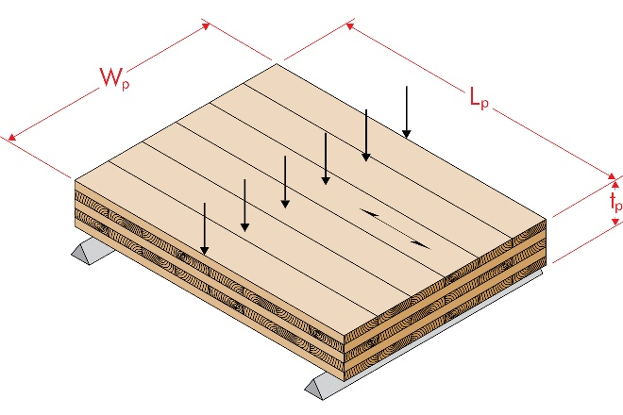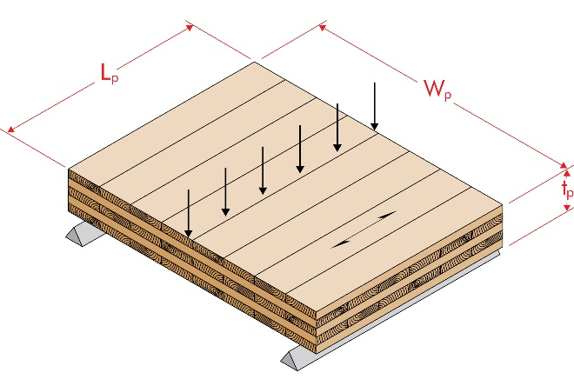

Figure 2. Flatwise bending in the major (left) and minor (right) CLT strength directions

Item 2017-6-02: Replace the entire Section 4, Symbols, as follows.
Rationale: Update the symbols for consistency with the revisions of this standard. Expand symbols for new edgewise CLT properties. Distinguish between CLT properties and lamination properties.

Ballot:
4. Symbols

4.1 CLT section and mechanical properties

Symbol | Definition | Reference(s)
E_{e,0} | Effective edgewise bending modulus of elasticity of CLT, in psi (MPa), in the major strength direction, used with I_{e,0} when calculating edgewise bending stiffness | 8.5.5.2
E_{e,90} | Effective edgewise bending modulus of elasticity of CLT, in psi (MPa), in the minor strength direction, used with I_{e,90} when calculating edgewise bending stiffness | 8.5.5.2
(EI)_{eff,f,0} | Effective flatwise bending stiffness of CLT, in lbf-in²/ft (N-mm²/m) of width, in the major strength direction | 8.5.3.2 and Tables A2 and A4
(EI)_{eff,f,90} | Effective flatwise bending stiffness of CLT, in lbf-in²/ft (N-mm²/m) of width, in the minor strength direction | 8.5.4.1 and Tables A2 and A4
f_{b,e,0} | Effective LSD specified edgewise bending strength of CLT, in MPa, in the major strength direction, used with S_{e,0} when calculating LSD edgewise bending moment resistance. | 8.5.5.2
F_{b,e,0} | Effective ASD reference edgewise bending stress of CLT, in psi, in the major strength direction, used with S_{e,0} when calculating ASD reference edgewise bending moment. | 8.5.5.2
f_{b,e,90} | Effective LSD specified edgewise bending strength of CLT, in MPa, in the minor strength direction, used with S_{e,90} when calculating LSD edgewise bending moment resistance. | 8.5.5.2
F_{b,e,90} | Effective ASD reference edgewise bending stress of CLT, in psi, in the minor strength direction, used with S_{e,90} when calculating ASD reference edgewise bending moment. | 8.5.5.2
(f_{b}S)_{eff,f,0} | Effective LSD flatwise bending moment resistance of CLT, in N-mm/m of width, in the major strength direction | 8.5.3.2 and Table A4
(F_{b}S)_{eff,f,0} | Effective ASD reference flatwise bending moment of CLT, in lbf-ft/ft of width, in the major strength direction | 8.5.3.2 and Table A2
(f_{b}S)_{eff,f,90} | Effective LSD flatwise bending moment resistance of CLT, in N-mm/m of width, in the minor strength direction | 8.5.3.2 and Table A4
(F_{b}S)_{eff,f,90} | Effective ASD reference flatwise bending moment of CLT, in lbf-ft/ft of width, in the minor strength direction | 8.5.3.2 and Table A2
f_{v,e,0} | LSD specified edgewise shear strength of CLT, in MPa, in the major strength direction, used with t_{p} when calculating LSD edgewise shear resistance. | 8.5.6.2
F_{v,e,0} | ASD reference edgewise shear stress of CLT, in psi, in the major strength direction, used with t_{p} when calculating ASD reference edgewise shear capacity. | 8.5.6.2
f_{v,e,90} | LSD specified edgewise shear strength of CLT, in MPa, in the minor strength direction, used with t_{p} when calculating LSD edgewise shear resistance. | 8.5.6.2
F_{v,e,90} | ASD reference edgewise shear stress of CLT, in psi, in the minor strength direction, used with t_{p} when calculating ASD reference edgewise shear capacity | 8.5.6.2
G_{e,0} | Effective modulus of rigidity (shear modulus) in edgewise bending of CLT, in psi (MPa), in the major strength direction, used with t_{p} when calculating edgewise shear stiffness | 8.5.6.2
G_{e,90} | Effective modulus of rigidity (shear modulus) in edgewise bending of CLT, in psi (MPa), in the minor strength direction, used with t_{p} when calculating edgewise shear stiffness | 8.5.6.2
(GA)_{eff,f,0} | Effective shear stiffness in flatwise bending of CLT in lbf/ft (N/m) of width in the major strength direction | 8.5.4.2 and Tables A2 and A4
(GA)_{eff,f,90} | Effective shear stiffness in flatwise bending of CLT in lbf/ft (N/m) of width in the minor strength direction | 8.5.4.2 and Tables A2 and A4
I_{e,0} | Gross moment of inertia of CLT in edgewise bending in the major strength direction, in in.⁴ (mm⁴), for a specific panel width (beam depth), calculated as W_{p}³ t_{p}/12 $\frac{{W_{p}}^{3}t_{p}}{12}$ | 8.5.5.2
I_{e,90} | Gross moment of inertia of CLT in edgewise bending in the minor strength direction, in in.⁴ (mm⁴), for a specific panel length (beam depth), calculated as L_{p}³ t_{p}/12 $\frac{{L_{p}}^{3}t_{p}}{12}$ | 8.5.5.2
L_{p} | Length of CLT panel in ft (m), measured in the major strength direction | Figures 1 and 2
S_{e,0} | Gross section modulus of CLT in edgewise bending in the major strength direction, in in.³ (mm³) for a specific CLT width (beam depth), calculated as W_{p}² t_{p}/6 $\frac{{W_{p}}^{2}t_{p}}{6}$ | 8.5.5.2
S_{e,90} | Gross section modulus of CLT in edgewise bending in the minor strength direction, in in.³ (mm³) for a specific CLT length (beam depth), calculated as L_{p}² t_{p}/6 $\frac{{L_{p}}^{2}t_{p}}{6}$ | 8.5.5.2
t_{p} | Gross thickness of CLT panel, in in. (mm) | Figures 1 and 2, Tables A2 and A4, and 8.5.6.2
v_{s,0} | LSD flatwise shear resistance, in N/m of width, in the major strength direction | 8.5.4.2 and Table A4
V_{s,0} | ASD reference flatwise shear capacity, in lbf/ft of width, in the major strength direction | 8.5.4.2 and Table A2
v_{s,90} | LSD flatwise shear strength, in N/m of width, in the minor strength direction | 8.5.4.2 and Table A4
V_{s,90} | ASD reference flatwise shear capacity, in lbf/ft of width, in the minor strength direction | 8.5.4.2 and Table A2
W_{p} | Width of CLT panel in ft (m), measured in the minor strength direction | Figures 1 and 2
4.2 Lamination mechanical properties

Symbol | Definition | Reference(s)
E | Modulus of elasticity of a lamination, in psi (MPa) | Tables 1, A1, and A3
f_{b} | Characteristic bending strength or LSD specified bending strength of a lamination, in psi (MPa) | Tables 1 and A3
F_{b} | ASD reference bending stress of a lamination, in psi | Table A1
f_{c} | Characteristic axial compressive strength or LSD specified axial compressive strength of a lamination, in psi (MPa) | Tables 1 and A3
F_{c} | ASD reference axial compressive stress of a lamination, in psi | Table A1
f_{s} | Characteristic planar (rolling) shear strength or LSD specified planar (rolling) shear strength of a lamination, in psi (MPa) | Tables 1 and A3
F_{s} | ASD reference planar (rolling) shear stress of a lamination, in psi | Table A1
f_{t} | Characteristic axial tensile strength or LSD specified axial tensile strength of a lamination, in psi (MPa) | Tables 1 and A3
F_{t} | ASD reference axial tensile stress of a lamination, in psi | Table A1
f_{v} | Characteristic shear strength or LSD specified shear strength of a lamination, in psi (MPa) | Tables 1 and A3
F_{v} | ASD reference shear stress of a lamination, in psi | Table A1
G | Modulus of rigidity (shear modulus) of a lamination, in psi (MPa) | Tables A1, and A3

Item 2017-6-03: Revise labels in Tables A2 and A4 as follows.
Rationale: Editorially update the labels for consistency with the symbols revised in Item 2017-6-02.

Ballot:

Replace LABELS of Table A2 and A4 as follows:

Table A2. ASD Reference Design Values ^{(a,b,c)} in Flatwise Bending for CLT Listed in Annex A (for use in the U.S.)
CLT Layup | t_{p} (in.) | Lamination Thickness (in.) in CLT Layup |  |  |  |  |  |  | Major Strength Direction |  |  |  | Minor Strength Direction
 |  | = | ⊥ | = | ⊥ | = | ⊥ | = | (F_{b}S)_{eff,f,0}  (lbf-ft/ft of width) | (EI)_{eff,f,0}  (10⁶ lbf-in.²/ft of width) | (GA)_{eff,f,0}  (10⁶ lbf/ft of width) | V_{s,0}  (lbf/ft of width) | (F_{b}S)_{eff,f,90}  (lbf-ft/ft of width) | (EI)_{eff,f,90}  (10⁶ lbf-in.²/ft of width) | (GA)_{eff,f,90}  (10⁶ lbf/ft of width) | V_{s,90}  (lbf/ft of width)

Table A4. LSD Stiffness and Resistance Values ^{(a,b,c)} in Flatwise Bending for CLT Listed in Annex A (for use in Canada)
CLT Layup | t_{p} (mm) | Lamination Thickness (mm) in CLT Layup |  |  |  |  |  |  | Major Strength Direction |  |  |  | Minor Strength Direction
 |  | = | ⊥ | = | ⊥ | = | ⊥ | = | (f_{b}S)_{eff,f,0}  (10⁶ N-mm/m of width) | (EI)_{eff,f,0}  (10⁹ N-mm²/m of width) | (GA)_{eff,f,0}  (10⁶ N/m of width) | v_{s,0}  (kN/m of width) | (f_{b}S)_{eff,f,90}  (10⁶ N-mm/m of width) | (EI)_{eff,f,90}  (10⁹ N-mm²/m of width) | (GA)_{eff,f,90}  (10⁶ N/m of width) | v_{s,90}  (kN/m of width)

Item 2017-6-04: Add in-plane shear and edgewise bending test methods as follows.
Rationale: This proposal is intended to add test methods for qualification of edgewise shear and bending properties. Revise existing qualification test language to coordinate with application of referenced test standards.

8.4.2: To use CLT with an integral header over an opening or in lateral design where CLT is used as part of a shear wall or horizontal diaphragm, edgewise properties are usually required. While there are no reliable analytical methodologies to calculate such properties, empirical methods have been adopted by the industry and therefore, it is proposed to be added to this standard as optional qualification tests (see new Sections 8.5.5 and 8.5.6). It is proposed that the edgewise bending and shear strength and stiffness be added to this standard as optional qualification tests, when the need is determined by the CLT manufacturer.

The current sections 8.5.3 to 8.5.6 have been reorganized to provide a secondary section on each material property subject. For example 8.5.3 is now the test method and requirements for “flatwise” bending properties with sub-sections on test methods and qualification requirements.

8.5.3. The LSD specified bending moment resistance for CLT in Canada is derived by multiplying the characteristic bending capacity (5th percentile with 75% confidence) times the bending normalization factor of 1.2 and the standard load duration factor of 0.8. Therefore, the characteristic bending moment capacity from qualification tests shall be no less than the LSD specified bending moment resistance divided by 0.96.

8.5.4: Similar to 8.5.3, the shear normalization factor with a reliability index (β) of 2.6 and coefficient of variation of 15% remains at 0.8 based on the standard practice for CSA O86. In the U.S., since the shear tests is full-scale, the adjust factor of 2.1 is justifiable based on ASTM D5456 for SCL and D3737 for glulam.

8.5.5 The edgewise test method is added. For flatwise bending test method in the minor strength direction, the span-to-depth ratio of 30:1 usually results in a very large deflection, as noted in the U.S. CLT handbook. Therefore, it is proposed to reduce the ratio to 18:1.

8.5.6: An in-plane shear capacity test method is proposed for adoption in this standard based on Annex A3 of ASTM D5456. It has been demonstrated by the CLT industry that this referenced test method can be used for CLT in determining the in-plane shear capacity. It has also been adopted by ICC-ES in its AC455.

8.5.6: An in-plane shear rigidity test method is proposed for adoption in this standard based on ASTM D198. It has been demonstrated by the CLT industry that this referenced test method can be used for CLT in determining the in-plane shear rigidity.

Ballot: Replace Sections 8.4 and 8.5 as follows:

8.4 Qualification for Structural Performance
Following plant pre-qualification, a representative sample of CLT panels shall be manufactured for qualification tests in accordance with 8.4.1 and 8.4.2. Depending on the number of layups intended for qualification, a qualification plan shall be developed and accepted by an approved agency in accordance with the principles prescribed in this section.

8.4.1 Required mechanical property qualification
The flatwise bending and flatwise shear properties of CLT layups in both major and minor strength directions shall be tested in accordance with 8.5.3 and 8.5.4 to confirm the design values shown in Table A2 for use in the US or Table A4 for use in Canada, or the design values approved by an approved agency.

8.4.2 Optional mechanical property qualification
When edgewise bending and edgewise shear properties are to be published by the CLT manufacturer approved by an approved agency, qualification tests shall be conducted in accordance with 8.5.5 and 8.5.6, respectively.

8.5 Mechanical Property Qualification
The design values from required mechanical property qualification (8.4.1) and optional mechanical property qualification (8.4.2) shall be approved by an approved agency in accordance with this section.

[8.5.1 and 8.5.2 unchanged by this ballot item]

8.5.3 Flatwise bending properties
Flatwise bending stiffness and bending moment shall be evaluated in accordance with 8.5.3.1 and 8.5.3.2

8.5.3.1 Flatwise bending test methods
Flatwise bending tests shall be conducted in both major and minor strength directions in accordance with the third-point load method of Sections 4 through 12 of ASTM D198 or Section 8 of ASTM D4761 using the specimen width of not less than 12 inches (305 mm) and the on-center span equal to approximately 30 times the specimen depth for the tests in the major strength direction and approximately 18 times the specimen depth for the tests in the minor strength direction. The weight of the CLT panel is permitted to be included in the determination of the flatwise bending moment.

8.5.3.2 Flatwise bending qualification requirements
In the U.S. and Canada, the average flatwise bending stiffness determined from qualification tests shall equal or exceed the published flatwise bending stiffness [(EI)_{eff,f,0} or (EI)_{eff,f,90}].

In the U.S., the characteristic flatwise bending moment determined from qualification tests shall equal or exceed the published ASD reference flatwise bending moment [(F_{b}S)_{eff,f,0} or (F_{b}S)_{eff,f,90}] times 2.1. In Canada, the characteristic flatwise bending moment determined from qualification tests shall equal or exceed the published LSD flatwise bending resistance [(f_{b}S)_{eff,f,0} or (f_{b}S)_{eff,f,90}] divided by 0.96.

8.5.4 Flatwise shear properties
Flatwise shear stiffness and capacity (resistance) shall be evaluated in accordance with 8.5.4.1 and 8.5.4.2.

8.5.4.1 Flatwise shear test methods
Flatwise shear stiffness tests shall be conducted in both major and minor strength directions in accordance with Sections 45 through 52 of ASTM D198.

Flatwise shear tests shall be conducted in both major and minor strength directions in accordance with the center-point load method of Sections 4 through 12 of ASTM D198 or Section 7 of ASTM D4761 using the specimen width of not less than 12 inches (305 mm) and the on-center span equal to 5 to 6 times the specimen depth. The bearing length shall be sufficient to avoid bearing failure, but not greater than the specimen depth. All specimens are to be cut to length with no overhangs allowed.

8.5.4.2 Flatwise shear qualification requirements
In the U.S. and Canada, the average flatwise shear stiffness determined from qualification tests shall be permitted to be the published shear stiffness in flatwise bending [(GA)_{eff,f,0} or (GA)_{eff,f,90}].

In the US, the characteristic flatwise shear capacity determined from qualification tests shall equal or exceed the published ASD reference flatwise shear capacity (V_{s,0} or V_{s,90}) times 2.1. In Canada, the characteristic flatwise shear resistance determined from qualification tests shall equal or exceed the published LSD flatwise shear resistance (v_{s,0} or v_{s,90}) divided by 0.96.

8.5.5. Edgewise bending properties
Edgewise bending stiffness and bending moment shall be permitted to be evaluated in accordance with 8.5.5.1 and 8.5.5.2. The volume, creep and load duration effects of edgewise bending shall be evaluated in accordance with the principles of Sections 7.4.1 and 7.4.2 of ASTM D5456.

8.5.5.1 Edgewise bending test methods
Bending tests shall be conducted edgewise in both major and minor strength directions in accordance with the third-point load method of Sections 4 through 12 of ASTM D198 or Section 6 of ASTM D4761 using the specimen depth of not less than 12 inches (305 mm) and the on-center span equal to approximately 18 times the specimen depth. The weight of the CLT panel is permitted to be included in the determination of the edgewise bending moment.

8.5.5.2 Edgewise bending qualification requirements
In the U.S. and Canada, the average edgewise bending stiffness determined from qualification tests divided by the calculated moment of inertia (I_{e,0} or I_{e,90}) shall equal or exceed the published edgewise bending modulus of elasticity (E_{e,0} or E_{e,90}).

In the U.S., the characteristic edgewise bending moment determined from qualification tests shall equal or exceed the published ASD reference edgewise bending stress (F_{b,e,0} or F_{b,e,90}) multiplied by the calculated edgewise section modulus (S_{e,0} or S_{e,90}) and an adjustment factor of 2.1. In Canada, the characteristic edgewise bending moment determined from qualification tests shall equal or exceed the published LSD specified edgewise bending strength (f_{b,e,0} or f_{b,e,90}) multiplied by the calculated edgewise section modulus (S_{e,0} or S_{e,90}) and divided by an adjustment factor of 0.96.

8.5.6. Edgewise shear properties
Edgewise shear stiffness and capacity (resistance) shall be permitted to be evaluated in accordance with 8.5.6.1 and 8.5.6.2.

8.5.6.1 Edgewise shear test methods
Edgewise shear stiffness tests shall be conducted in both major and minor strength directions in accordance with Sections 45 through 52 of ASTM D198.

Edgewise shear capacity (resistance) tests shall be conducted in both major and minor strength directions in accordance with the full-scale test method specified in Annex A3 of ASTM D5456. The web thickness of the I-shaped cross section shall be the CLT thickness. The specimen shall contain at least one edge joint, as applicable, in the middle 1/3 of the specimen depth.

Note: Tests have demonstrated that reinforcing the specimens with flanges (creating I-shaped beams) is necessary for development of the shear failure mode. Conducting preliminary tests to confirm the failure mode is recommended prior to producing the entire batch of I-shaped test specimens. Tests have also demonstrated that it may not be possible to fail the 7-ply or thicker CLT beams in shear in both minor and major strength directions. High-capacity testing apparatus is needed in all cases.

8.5.6.2 Edgewise shear qualification requirements
For use in the US or Canada, the average edgewise shear stiffness determined from qualification tests divided by the gross thickness of CLT (t_{p}) shall be permitted to be the published modulus of rigidity (shear modulus) in edgewise bending (G_{e,0} or G_{e,90}).

In the US, the characteristic edgewise shear capacity determined from qualification tests shall equal or exceed the published ASD reference edgewise shear capacity (F_{v,e,0} t_{p} or F_{v,e,90} t_{p}) multiplied by an adjustment factor of 2.1. In Canada, the characteristic edgewise shear capacity determined from qualification tests shall equal or exceed the published LSD edgewise shear resistance (f_{v,e,0} t_{p} or f_{v,e,90} t_{p}) divided by an adjustment factor of 0.96.

