ANSI/APA PRR 410-2016 (Ballot 2016-1)
Ballot issue date: 02/23/2016 Ballot closing date: 03/24/2016

Ballot Instructions:
- All members are required to return the letter ballot. Failure to return 3 consecutive letter ballots will lead to the termination of the membership from this committee.
- All votes shall be cast by marking the appropriate column of each ballot item.
- Ballot items marked Negative or Affirmative-with-Comment shall be accompanied by a written explanation and proposed resolution that would address the negative using the comment form at the end of this ballot form.
Exception: A written explanation and proposed resolution is not required for a ballot item to find a negative non-persuasive.
- Return ballot by e-mail to borjen.yeh@apawood.org. Please attach the completed ballot and comments as a word processor file (e.g., Microsoft Word) to facilitate the collection of comments for committee actions.

Committee Member Name |  | Signature (not required with e-mail) |  | Date

Ballot (Aff = affirmative; Aw/C = affirmative with comment; Neg = negative; Abst = abstention)

Item | Description | Aff | Aw/C | Neg | Abst
2016-1-01 | Revise Section 2
2016-1-02 | Revise Table 2
2016-1-03 | Revise Figure 2
2016-1-04 | Revise Section 8.2.2
2016-1-05 | Revise Table A1
2016-1-06 | Revise Table A1A

Ballot Comment Form for ANSI/APA PRR 410-2016 (Ballot 2016-1)
Required only for Negative or Affirmative-with-Comment
Please attach this page to the e-mail ballot return

Item | Comments
2016-1-01
2016-1-02
2016-1-03
2016-1-04
2016-1-05
2016-1-06

Ballot Item 2016-1-01: Revise Section 2 as proposed
Rationale: Update references

Ballot:

Referenced Documents

This standard incorporates dated references. These normative references are cited at the appropriate places in the text. Subsequent amendments or revisions to these references apply to this standard only when incorporated into this standard by amendments or revisions.

ASTM Standards:

D9-12 Standard Terminology Relating to Wood and Wood-Based Products

D198-15 Standard Test Methods of Static Tests of Lumber in Structural Sizes
D1037-12 Standard Test Methods for Evaluating Properties of Wood-Base Fiber and Particle Panel Materials
D2395-14e1 Standard Test Methods for Specific Gravity of Wood and Wood-Base Materials
D2915-10 Sampling and Data-Analysis for Structural Wood and Wood-Based Products
D3501-05a(2011) Standard Test Methods for Wood-Based Structural Panels in Compression
D3737-12 Standard Practice for Establishing Stresses for Structural Glued Laminated Timber (Glulam)
D4761-13 Standard Test Methods for Mechanical Properties of Lumber and Wood-Based Structural Material
D5456-14b Standard Specification for Evaluation of Structural Composite Lumber Products
D7672-11 Standard Specification for Evaluating Structural Capacities of Rim Board Products and Assemblies
F1667-15 Standard Specification for Driven Fasteners: Nails, Spikes, and Staples

Other Standards:

ANSI/AWC NDS-2015 National Design Specification for Wood Construction
ANSI/AWC SDPWS-2015 Special Design Provisions for Wind and Seismic
ANSI A190.1-2012 Structural Glued Laminated Timber
ANSI/ASME Standard B18.2.1-2012 Square and Hex Bolts and Screws (Inch Series)
APA D510-2012 Panel Design Specification
APA Y510-1997 Plywood Design Specification
CSA B111-1974 (R2003) Wire Nails, Spikes and Staples
CSA O86-14 Engineering Design in Wood
CSA O121-08 (R2013) Canadian Douglas Fir Plywood
CSA O122-06 Structural Glued-Laminated Timber
CSA O151-09 (R2014) Canadian Softwood Plywood
CAN/CSA O325-07 (R2012) Construction Sheathing
US Product Standard PS 1-09 Structural Plywood
US Product Standard PS 2-10 Performance Standard for Wood-Based Structural-Use Panels

Ballot Item 2016-1-02: Revise Table 2 as proposed
Rationale: The concentrated vertical load capacity can be applied to rim board depth of no more than 24 inches.

Ballot:
Table 2. Required Mean Test Values ^{(a)} at As-Received Moisture Conditions for Engineered Wood Rim Boards
Rim Board Grade | Performance Category^{(b)} | H^{(c)}  (lbf/ft) | V^{(d)}  (lbf/ft) |  | Z^{(e)}  (lbf) | P^{(f)}  (lbf)
 |  | Depth (d) Limitation (in.)
 |  | d ≤ 24 | d ≤ 16 | 16 < d ≤ 24 | d ≤ 24 | d ≤ 24
A | 1-1/4 or higher | 675 | 15,450 | 9,600 | 2,190 | 10,500
B1 | 1-1/4 or higher | 560 | 15,450 | 9,600 | 2,190 | 10,500
B2 | 1-1/8 or higher | 560 | 14,550 | 9,600 | 2,190 | 10,500
C1 | 1-1/8 or higher | 505 | 13,200 | 9,000 | 2,190 | 10,500
C2 | 1 or higher | 505 | 9,900 | 4,950 | 1,875 | 10,500

Ballot Item 2016-1-03: Revise Figure 2 as proposed
Rationale: PRR 410-2011 has been adopted by the 2015 International Building Code and International Residential Code. When the standard was adopted, ICC identified some wording in the standard as non-mandatory. This revision is intended to address this issue.

Ballot:
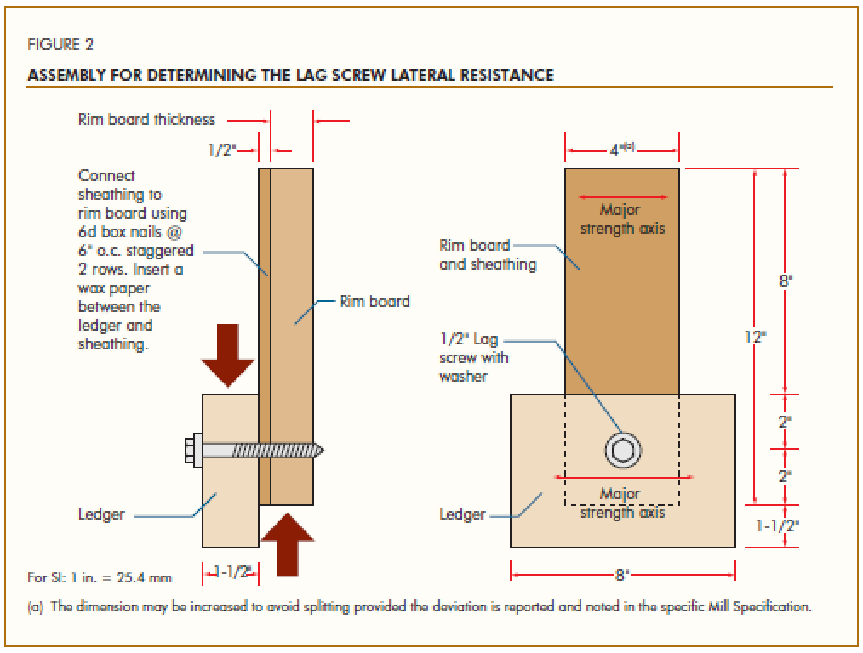

Change Note (a) to “The dimension shall be permitted to be increased to avoid splitting….”
Ballot Item 2016-1-04: Revise Section 8.2.2 as proposed
Rationale: PRR 410-2011 has been adopted by the 2015 International Building Code and International Residential Code. When the standard was adopted, ICC identified some wording in the standard as non-mandatory. This revision is intended to address this issue.

Ballot:
8.2.2 Engineered wood rim board quality assurance requirements shall be permitted to be considered satisfied when the requirements for the referenced standards in Section 2 and any additional requirements listed in Section 8.3 are met.

Ballot Item 2016-1-05: Revise Table A1 as proposed
Rationale: The concentrated vertical load capacity can be applied to rim board depth of no more than 24 inches.

Ballot:
Table A1. Allowable Design Values ^{(a)} for Engineered Wood Rim Boards
Rim Board Grade | Performance Category^{(b)} | H^{(c)}  (lbf/ft) | V^{(d)}  (lbf/ft) |  | Z^{(e)}  (lbf) | P^{(f)}  (lbf)
 |  | Depth (d) Limitation (in.)
 |  | d ≤ 24 | d ≤ 16 | 16 < d ≤ 24 | d ≤ 24 | d ≤ 24
A | 1-1/4 or higher | 240 | 5,150 | 3,200 | 350 | 3,500
B1 | 1-1/4 or higher | 200 | 5,150 | 3,200 | 350 | 3,500
B2 | 1-1/8 or higher | 200 | 4,850 | 3,200 | 350 | 3,500
C1 | 1-1/8 or higher | 180 | 4,400 | 3,000 | 350 | 3,500
C2 | 1 or higher | 180 | 3,300 | 1,650 | 300 | 3,500

Ballot Item 2016-1-06: Revise Table A1A as proposed
Rationale: The concentrated vertical load capacity can be applied to rim board depth of no more than 24 inches. The symbols for factored resistances are updated for consistency with the Canadian Limit States Design. The factored uniform vertical load capacity for C1 grade at less than 16 inches in depth (7,739) contains a typo of 7,339 (i.e., 4,400 x 1.668 = 7,339).

Ballot:
Table A1A. Limit States Design Values ^{(a)} for Engineered Wood Rim Boards
Rim Board Grade | Performance Category^{(b)} | H_{r}^{(c)}  (lbf/ft) | V_{r}^{(d)}  (lbf/ft) |  | Z_{r}^{(e)}  (lbf) | P_{r}^{(f)}  (lbf)
 |  | Depth (d) Limitation (in.)
 |  | d ≤ 24 | d ≤ 16 | 16 < d ≤ 24 | d ≤ 24 | d ≤ 24
A | 1-1/4 or higher | 313 | 8,590 | 5,338 | 584 | 5,838
B1 | 1-1/4 or higher | 261 | 8,590 | 5,338 | 584 | 5,838
B2 | 1-1/8 or higher | 261 | 8,090 | 5,338 | 584 | 5,838
C1 | 1-1/8 or higher | 235 | 7,339 | 5,004 | 584 | 5,838
C2 | 1 or higher | 235 | 5,504 | 2,752 | 500 | 5,838

For SI: 1 in. = 25.4 mm, 1 lbf/ft = 0.0146 N/mm, 1 lbf = 4.448 N
^{(a)} These design values are applicable to standard-term load duration and permitted to be adjusted for other load durations in accordance with the applicable building code. Factors for ASD to LSD conversion are shown in Appendix B.
^{(b)} Performance categories listed in this standard.
^{(c)} H_{r} = Factored horizontal (shear) load transfer resistance based on the attachment schedule specified in this standard. This capacity represents the total of the lateral loads transferred through the rim board by both the floor sheathing and wall plate above the floor sheathing.
^{(d)} V_{r} = Factored uniform vertical (compression) load resistance.
^{(e)} Z_{r} = Factored lateral resistance of a 1/2-inch (12.7-mm) diameter lag screw in compliance with the connection requirements tested in this standard.
^{(f)} P_{r} = Factored concentrated vertical load resistance based on a 4-1/2-inch (114-mm) bearing length.

