ANSI/APA PRR 410-2016 (Ballot 2016-2)
Ballot issue date: 02/23/2016 Ballot closing date: 03/24/2016

Ballot Instructions:
- All members are required to return the letter ballot. Failure to return 3 consecutive letter ballots will lead to the termination of the membership from this committee.
- All votes shall be cast by marking the appropriate column of each ballot item.
- Ballot items marked Negative or Affirmative-with-Comment shall be accompanied by a written explanation and proposed resolution that would address the negative using the comment form at the end of this ballot form.
Exception: A written explanation and proposed resolution is not required for a ballot item to find a negative non-persuasive.
- Return ballot by e-mail to borjen.yeh@apawood.org. Please attach the completed ballot and comments as a word processor file (e.g., Microsoft Word) to facilitate the collection of comments for committee actions.

Committee Member Name |  | Signature (not required with e-mail) |  | Date

Ballot (Aff = affirmative; Aw/C = affirmative with comment; Neg = negative; Abst = abstention)

Item | Description | Aff | Aw/C | Neg | Abst
2016-2-01 | Revise Section 1.4
2016-2-02 | Add new Section 3.2.2
2016-2-03 | Add new Section 5.1.4
2016-2-04 | Revise Section 5.2.1
2016-2-05 | Add new Section 5.2.4 and Table 3
2016-2-06 | Add new Section 6.6
2016-2-07 | Add new Tables A2 and A2ARevise Section 8.3.1
2016-2-08 | Revise Section 8.2.2 Add new Tables A2 and A2A
2016-2-09 | Add new Annex B

Ballot Comment Form for ANSI/APA PRR 410-2016 (Ballot 2016-2)
Required only for Negative or Affirmative-with-Comment
Please attach this page to the e-mail ballot return

Item | Comments
2016-2-01
2016-2-02
2016-2-03
2016-2-04
2016-2-05
2016-2-06
2016-2-07
2016-2-08
2016-2-09

Ballot Item 2016-2-01: Revise Section 1.4 as proposed
Rationale: To permit the use of mat-formed and composite panel rim boards in limited bending applications (max span of 4 feet)

Ballot:
1.4 This standard provides dimensions and tolerances, performance requirements, test methods, quality assurance, and trademarking for engineered wood rim boards. The use of engineered wood rim boards in bending applications is limited to a design span of 4 feet or less for rim boards manufactured from mat-formed and composite panels provided that the design load is no greater than the allowable load tabulated in Annex B.

Ballot Item 2016-2-02: Add a new Section 3.2.2 as proposed
Rationale: To define edgewise bending properties

Ballot:

Edgewise Bending Properties – The mechanical properties of rim boards, including allowable bending stress (F_{be}) and modulus of elasticity (E_{e}) when subjected to loading on the edge of the rim boards. The edgewise bending properties for rim boards manufactured from mat-formed and composite panels when qualified in accordance with this standard are limited to a design span of 4 feet or less provided that the design load is no greater than the allowable load tabulated in Annex B.

Ballot Item 2016-2-03: Add a new Section 5.1.4 as proposed
Rationale: This provision specifies the minimum number of samples required for edgewise bending qualification.

Ballot:

For rim boards manufactured from mat-formed and composite panels, a minimum of 28 specimens shall be sampled from representative production and tested for edgewise bending strength and modulus of elasticity in accordance with Section 6.6.

Ballot Item 2016-2-04: Revise Section 5.2.1 as proposed
Rationale: This provision specifies the requirements for edgewise bending qualification.

Ballot:

The structural performance for engineered wood rim boards shall include the horizontal load transfer capacity, uniform vertical load capacity, 1/2-inch (12.7-mm) diameter lag screw lateral resistance, concentrated vertical load capacity, and edgewise bending properties when applicable, of the product under evaluation.

Ballot Item 2016-2-05: Add new Section 5.2.4 and Table 3 as proposed
Rationale: This new section prescribes the minimum requirements for edgewise bending properties of mat-formed and composite panel rim boards.

Ballot:

The edgewise bending strength and modulus of elasticity of rim boards shall be evaluated based on the test methods described in Section 6.6 and meet the minimum requirements specified in Table 3 when the rim boards are manufactured from mat-formed and composite panels.

Table 3. Required Edgewise Bending Values for Rim Boards Manufactured from Mat-Formed and Composite Panels ^{(a)}
Grade | f_{be}^{(b)} (psi) | E_{e}^{(c)} (psi)
All | 2,070 | 580,000
^{(a)} The tabulated values are test values. The allowable stress design (for the U.S.) and limit states design (for Canada) values are provided in Annex A.
^{(b)} Characteristic (5th percentile with 75% confidence) edgewise bending strength.
^{(c)} Characteristic (mean) edgewise modulus of elasticity.

Note: The edgewise bending creep and duration of load performance of mat-formed and composite panels is not required in this standard based on the results of an independent study in accordance with ASTM D6815 using a combination of representative products from 3 manufacturers¹ and more than 15 years of field experience under the application limitations and design values specified in this standard.

¹ APA. 2011. Creep Testing of 1-1/8-inch Oriented Strand Board (OSB) APA Rim Board Plus. APA Report T2011L-37. Tacoma, WA (available at http://www.apawood.org).

Ballot Item 2016-2-06: Add new Section 6.6 as proposed
Rationale: This new section specifies the edgewise bending test methods for this standard.

Ballot:

Test Method RB-5, Edgewise Bending Strength and Modulus of Elasticity

The edgewise bending specimens with a dimension of 2 inches by 36 inches shall be sampled from representative production.

The edgewise bending specimens shall be tested using the method specified in Sections 6 through 11, Bending Edgewise, of ASTM D4761 with the exception that the load shall be applied at mid-span (center-point loading) using the test span of 33 inches. Prior to testing, all specimens shall be placed in indoor conditions for at least 1 week.

Ballot Item 2016-2-07: Revise Section 8.3.1 as proposed
Rationale: Add the edgewise bending QA to the standard.

Ballot:

Mechanical properties – Dry bending strength and stiffness in both the along and across directions, and redry (cycled in accordance with Section 7.16, Single Cycle Test, of PS 2) bending strength in the along direction (Section 7.6, Small Static Bending Test, of PS 2), of the product qualified under structural performance (Section 5.2 of this standard) shall be established in accordance with PS 2 or CSA O325. In addition, the edgewise bending strength and modulus of elasticity shall be tested in accordance with Section 6.6 and shall meet the values specified in Table 3.

Ballot Item 2016-2-08: Add new Tables A2 and A2A as proposed
Rationale: These tables provide design values for edgewise bending properties based on the same principle as other rim board design properties.

Ballot:
Table A2. Allowable Design Values ^{(a)} for Edgewise Bending Properties of Rim Boards Manufactured from Mat-Formed and Composite Panels
Grade | F_{be}^{(b)} (psi) | E_{e} (psi)
All | 600 | 550,000
For SI: 1 psi = 6.8948 kPa
^{(a)} The allowable values are the characteristic test values specified in Table 3 of this standard multiplied by the adjustment factors provided below. The design values are applicable to the normal load duration (10 years) for wood products and shall be adjusted for other load durations in accordance with the applicable building code.

Allowable edgewise bending stress (F_{be}): 1/3.45
Allowable edgewise bending modulus of elasticity (E_{e}): 1/1.05

Note: The adjustment factor of 3.45 for F_{be} is based on a combination of the following factors:
  - A factor of 2.1, which is the adjustment factor used to relate the test value to the allowable bending stress and includes the load duration factor of 1.6 from the test duration to the design load duration (10 years) and the factor of safety of 1.3.
  - A factor of 1.45, which accounts for an assumed volume effect between the qualification size of 2 inches by 33 inches and the maximum permissible span of 4 feet with a depth of 24 inches based on a 2-parameter Weibull theory by assuming a coefficient of variation of 15%.
  - A factor of 1.08, which relates the center-point loading configuration to the uniform load used in design.
  - A factor of 1.05, which accounts for the moisture effect on edgewise bending strength between the qualification (as-received) and standard moisture (65% RH and 68°F) conditions.

Note: The adjustment factor of 1.05 for E_{e} accounts for the moisture effect on edgewise modulus of elasticity between the qualification (as-received) and standard moisture (65% RH and 68°F) conditions.

Table A2A. Limit States Design Values for Edgewise Bending Properties of Rim Boards Manufactured from Mat-Formed and Composite Panels
Grade | f_{r,be}^{LSD (a)} (psi) | E_{e} (psi)
All | 998 | 550,000
For SI: 1 psi = 6.8948 kPa
^{(a)} The limit states design (LSD) factored edgewise bending strength, f_{be}^{LSD}, is applicable to standard-term load duration and permitted to be adjusted for other load durations in accordance with the applicable building code. The factor for ASD to LSD conversion is 1.663, which is a combination of the ϕ factor of 0.9, reliability normalization factor (K_{r}) of 0.88 from Table 14.2.3.2 of CSA O86, and the standard bending adjustment factor of 2.1.

Ballot Item 2016-2-09: Add Annex B as proposed
Rationale: This annex provides the maximum design load for PRR 410 rim boards when used as headers at the maximum span of no more than 4 feet.

Ballot:
Annex B. PRR 410 Rim Boards Used as Headers

Table B1. Allowable Loads for PRR 410 Rim Boards Used as Headers
(Load Duration Factor C_{D} = 1.0)
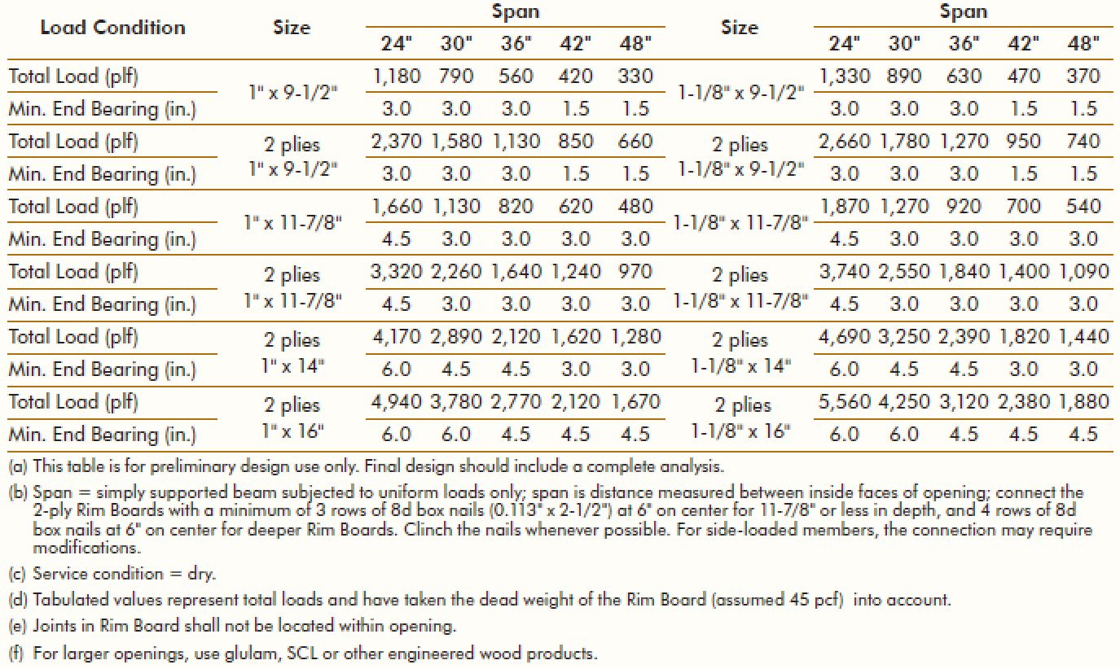

Table B1A. Maximum Limit States Factored Loads for PRR 410 Rim Boards Used as Headers (Standard-Term Load Duration K_{D} = 1.0)
Load Condition | Size | Span
 |  | 610 mm (24") | 762 mm (30") | 914 mm (36") | 1067 mm (42") | 1219 mm (48")
Total Load | 25 mm x 241 mm | 28.9 kN/m (1,980 plf) | 19.3 kN/m (1,322 plf) | 13.8 kN/m (946 plf) | 10.4 kN/m (713 plf) | 8.1 kN/m (555 plf)
Min. End Bearing | (1" x 9-1/2") | 76.2 mm (3 in.) | 76.2 mm (3 in.) | 76.2 mm (3 in.) | 76.2 mm (3 in.) | 38.1 mm (1-1/2 in.)
Total Load | 2 plies 15 mm x 241 mm | 57.8 kN/m (3,961 plf) | 38.6 kN/m (2,645 plf) | 27.6 kN/m (1,891 plf) | 20.7 kN/m (1,418 plf) | 16.1 kN/m (1,103 plf)
Min. End Bearing | (2 plies 1" x 9-1/2") | 76.2 mm (3 in.) | 76.2 mm (3 in.) | 76.2 mm (3 in.) | 76.2 mm (3 in.) | 38.1 mm (1-1/2 in.)
Total Load | 25 mm x 302 mm | 40.5 kN/m (2,775 plf) | 27.6 kN/m (1,891 plf) | 20 kN/m (1,370 plf) | 15.2 kN/m (1,042 plf) | 11.9 kN/m (815 plf)
Min. End Bearing | (1" x 11-7/8") | 114.3 mm (4-1/2 in.) | 114.3 mm (4-1/2 in.) | 76.2 mm (3 in.) | 76.2 mm (3 in.) | 76.2 mm (3 in.)
Total Load | 2 plies 25 mm x 302 mm | 81 kN/m (5,550 plf) | 55.3 kN/m (3,789 plf) | 40.1 kN/m (2,748 plf) | 30.4 kN/m (2,083 plf) | 23.8 kN/m (1,631 plf)
Min. End Bearing | (2 plies 1" x 11-7/8") | 114.3 mm (4-1/2 in.) | 114.3 mm (4-1/2 in.) | 76.2 mm (3 in.) | 76.2 mm (3 in.) | 76.2 mm (3 in.)
Total Load | 2 plies 25 mm x 356 mm | 101.7 kN/m (6,969 plf) | 70.6 kN/m (4,838 plf) | 51.8 kN/m (3,549 plf) | 39.6 kN/m (2,713 plf) | 31.3 kN/m (2,145 plf)
Min. End Bearing | (2 plies 1" x 14") | 152.4 mm (6 in.) | 152.4 mm (6 in.) | 114.3 mm (4-1/2 in.) | 114.3 mm (4-1/2 in.) | 114.3 mm (4-1/2 in.)
Total Load | 2 plies 25 mm x 406 mm | 120.4 kN/m (8,250 plf) | 92.2 kN/m (6,318 plf) | 67.7 kN/m (4,639 plf) | 51.8 kN/m (3,549 plf) | 40.9 kN/m (2,803 plf)
Min. End Bearing | (2 plies 1" x 16") | 190.5 mm (7-1/2 in.) | 152.4 mm (6 in.) | 152.4 mm (6 in.) | 114.3 mm (4-1/2 in.) | 114.3 mm (4-1/2 in.)
Total Load | 29 mm x 241 mm | 32.5 kN/m (2,227 plf) | 21.7 kN/m (1,487 plf) | 15.6 kN/m (1,069 plf) | 11.7 kN/m (802 plf) | 9.1 kN/m (624 plf)
Min. End Bearing | (1-1/8" x 9-1/2") | 76.2 mm (3 in.) | 76.2 mm (3 in.) | 76.2 mm (3 in.) | 76.2 mm (3 in.) | 38.1 mm (1-1/2 in.)
Total Load | 2 plies 29 mm x 241 mm | 65 kN/m (4,454 plf) | 43.5 kN/m (2,981 plf) | 31.1 kN/m (2,131 plf) | 23.3 kN/m (1,597 plf) | 18.1 kN/m (1,240 plf)
Min. End Bearing | (2 plies 1-1/8" x 9-1/2) | 76.2 mm (3 in.) | 76.2 mm (3 in.) | 76.2 mm (3 in.) | 76.2 mm (3 in.) | 38.1 mm (1-1/2 in.)
Total Load | 29 mm x 302 mm | 45.6 kN/m (3,125 plf) | 31.1 kN/m (2,131 plf) | 22.5 kN/m (1,542 plf) | 17.1 kN/m (1,172 plf) | 13.4 kN/m (918 plf)
Min. End Bearing | (1-1/8" x 11-7/8") | 114.3 mm (4-1/2 in.) | 114.3 mm (4-1/2 in.) | 76.2 mm (3 in.) | 76.2 mm (3 in.) | 76.2 mm (3 in.)
Total Load | 2 plies 29 mm x 302 mm | 91.2 kN/m (6,249 plf) | 62.2 kN/m (4,262 plf) | 45.1 kN/m (3,090 plf) | 34.2 kN/m (2,343 plf) | 26.8 kN/m (1,836 plf)
Min. End Bearing | (2 plies 1-1/8" x 11-7/8") | 114.3 mm (4-1/2 in.) | 114.3 mm (4-1/2 in.) | 76.2 mm (3 in.) | 76.2 mm (3 in.) | 76.2 mm (3 in.)
Total Load | 2 plies 29 mm x 356 mm | 114.4 kN/m (7,839 plf) | 79.4 kN/m (5,441 plf) | 58.3 kN/m (3,995 plf) | 44.6 kN/m (3,056 plf) | 35.2 kN/m (2,412 plf)
Min. End Bearing | (2 plies 1-1/8" x 14") | 152.4 mm (6 in.) | 152.4 mm (6 in.) | 114.3 mm (4-1/2 in.) | 114.3 mm (4-1/2 in.) | 114.3 mm (4-1/2 in.)
Total Load | 2 plies 29 mm x 406 mm | 135.5 kN/m (9,285 plf) | 95.6 kN/m (6,551 plf) | 71 kN/m (4,865 plf) | 54.8 kN/m (3,755 plf) | 43.5 kN/m (2,981 plf)
Min. End Bearing | (2 plies 1-1/8" x 16") | 190.5 mm (7-1/2 in.) | 152.4 mm (6 in.) | 152.4 mm (6 in.) | 114.3 mm (4-1/2 in.) | 114.3 mm (4-1/2 in.)
(a) This table is for preliminary design use only. Final design should include a complete analysis.
(b) Span = simply supported beam subjected to uniform loads only; span is distance measured between inside faces of opening; connect the 2-ply Rim Boards with a minimum of 3 rows of 8d box nails (0.113" x 2-1/2") at 152 mm (6") on center for 302 mm (11-7/8") or less in depth, and 4 rows of 8d box nails at 152 mm (6") on center for deeper Rim Boards. Clinch the nails whenever possible.
(c) Service condition = dry
(d) Tabulated values represent total loads and have taken the dead weight of the rim board (assumed 0.72 g/cm³ or 45 pcf) into account.
(e) Joints in rim board shall not be located within opening.
(f) For larger openings, use glulam, SCL or other engineered wood products.

